
Story

Date | 31 July 2026
Team ID
Project Name | Food Ordering Behaviour
Maximum Marks | 5 Marks

Activity 1: Story Design:
Story Visuals
Revenue Across Cities
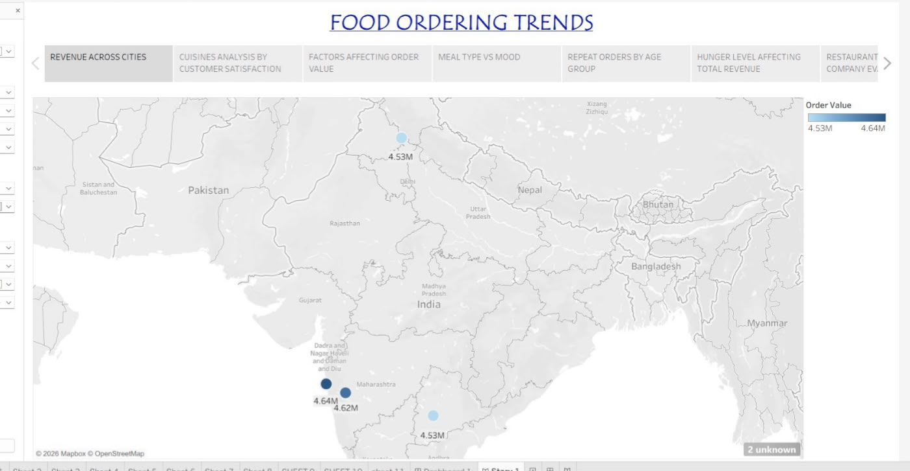

Cuisines Analysis by Customer Satisfaction
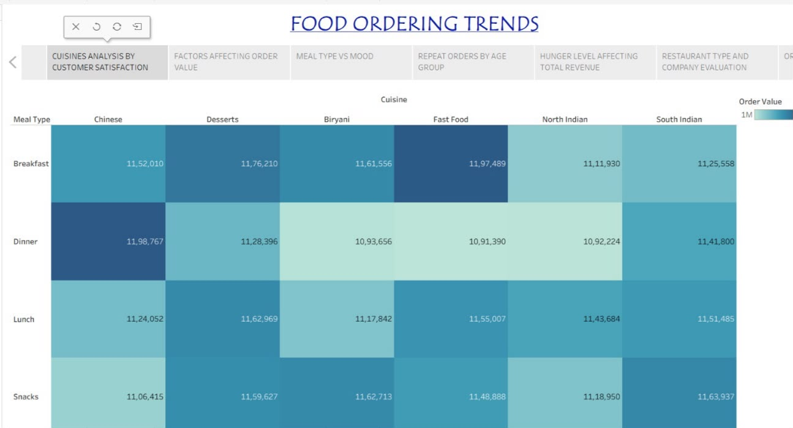

Factors Affecting Order Value
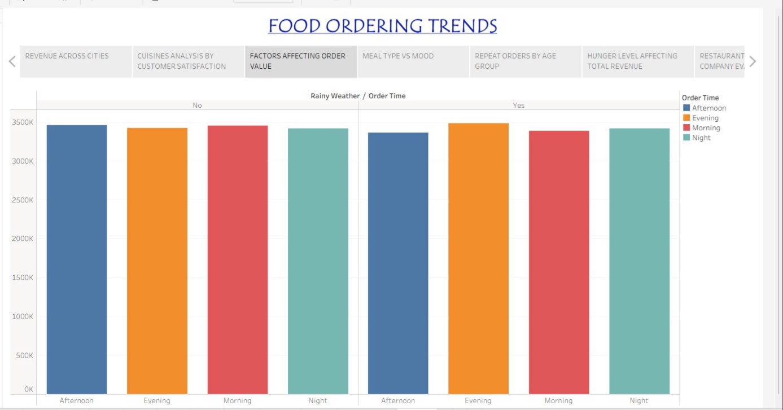

Meal Type vs Mood
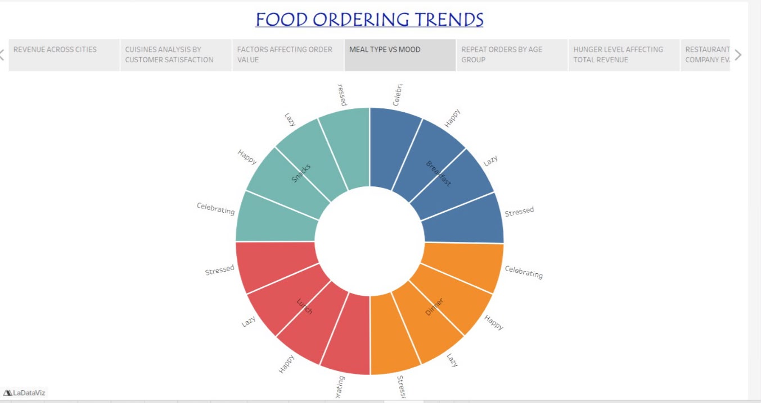

Repeat Orders by Age Group
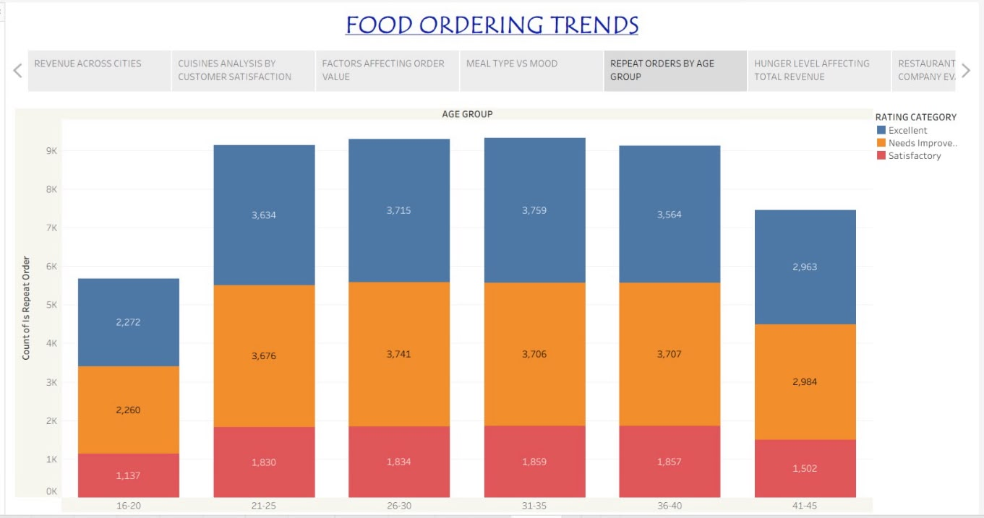

Hunger Level Affecting Total Revenue
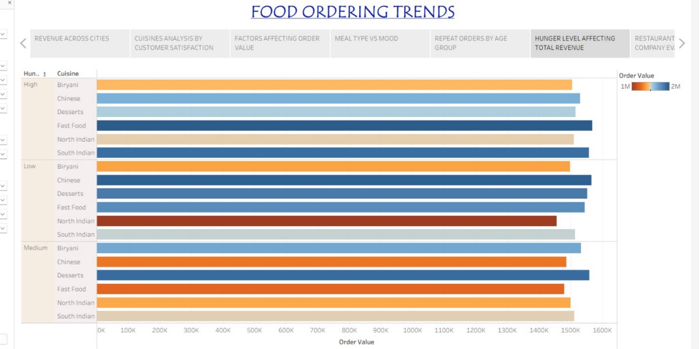

Restaurant Type and Company Evaluation
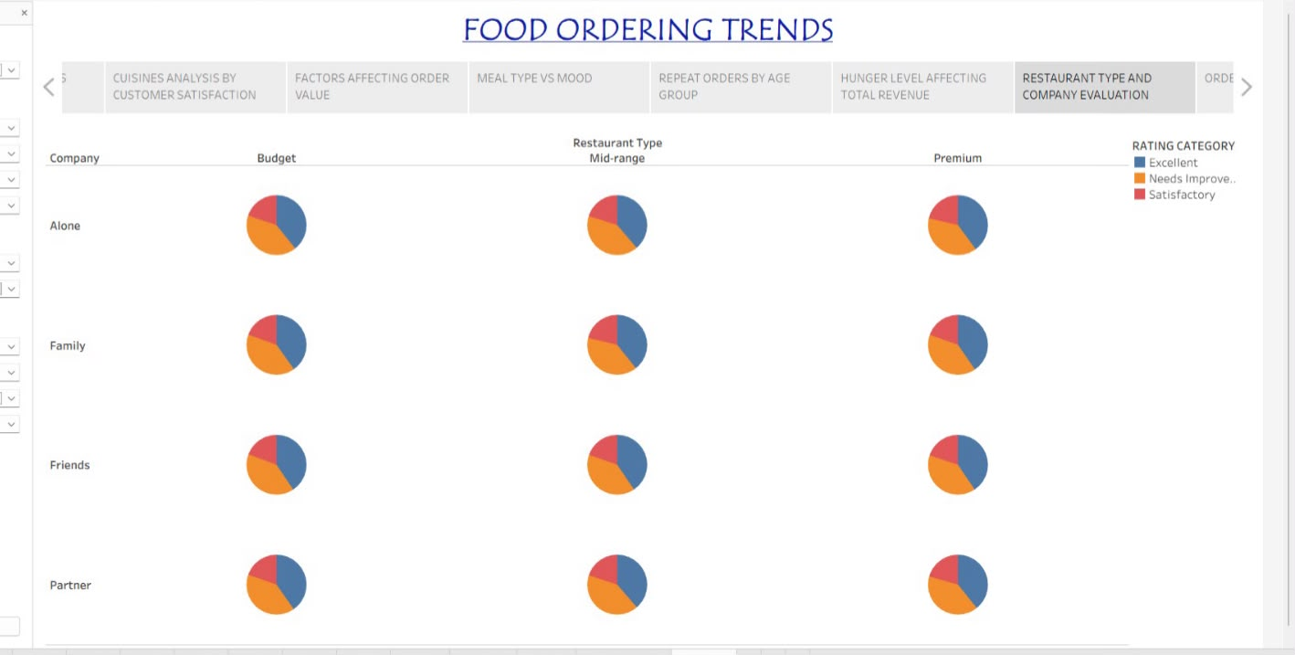

Ordering Time Analytics
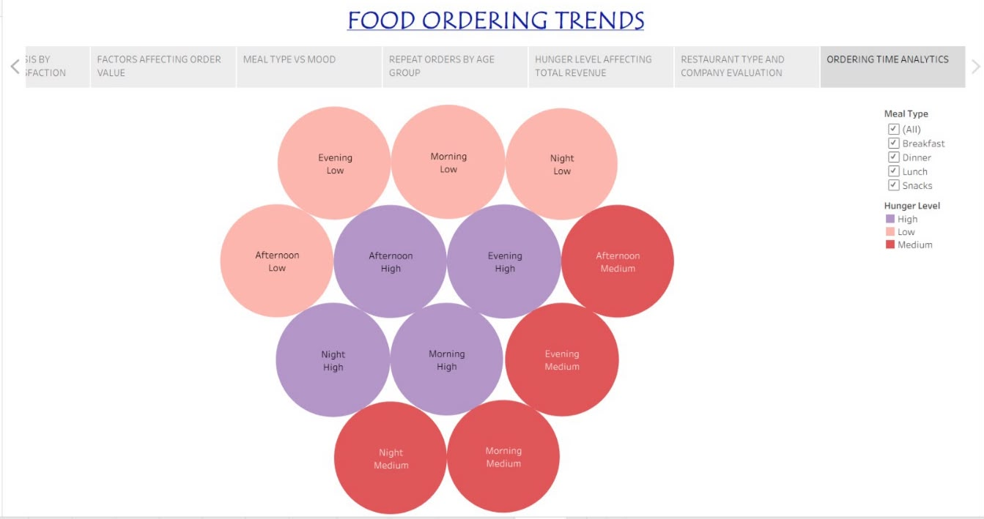

Story Point Explanation
Story Point 1: Revenue Across Cities
Which cities generate the highest order value? The story begins with a city-wise view of order value, using the map to compare revenue generated across locations and identify the stronger-performing cities.
Story Point 2: Cuisines Analysis by Customer Satisfaction
Which cuisine receives the highest number of customer ratings across different meal types? This story point compares cuisine performance across breakfast, dinner, lunch and snacks using the order-value/customer-satisfaction view.
Story Point 3: Factors Affecting Order Value
How does rainy weather influence order value across different times of the day? The comparison examines order value for afternoon, evening, morning and night under rainy and non-rainy conditions.
Story Point 4: Meal Type vs Mood
Variation of meal type ordered with variation in mood. The visual shows how meal types such as breakfast, lunch, dinner and snacks are associated with different customer moods.
Story Point 5: Repeat Orders by Age Group
How do customer ratings influence repeat orders among different age groups? The stacked bars compare repeat orders across age groups and rating categories, showing how rating levels vary with repeat-order behaviour.
Story Point 6: Hunger Level Affecting Total Revenue
Does hunger level affect spending on different cuisines? The visual compares order value across Biryani, Chinese, Desserts, Fast Food, North Indian and South Indian cuisines for high, medium and low hunger levels.
Story Point 7: Restaurant Type and Company Evaluation
How do customer rating categories vary across different restaurant types based on the customer’s dining company? The visual compares Excellent, Needs Improvement and Satisfactory ratings across Budget, Mid-range and Premium restaurants for different dining-company groups.
Story Point 8: Ordering Time Analytics
Which time of day generates the highest order value for each hunger level? The visual compares morning, afternoon, evening and night across high, medium and low hunger levels to show the ordering-time pattern.
Activity 2: Publish Story on Tableau Public and Paste Public link below
Tableau Story Link
https://public.tableau.com/app/profile/mehak.chugh/viz/FOODORDERINGTRENDS/Story1

